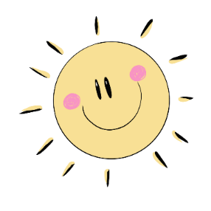
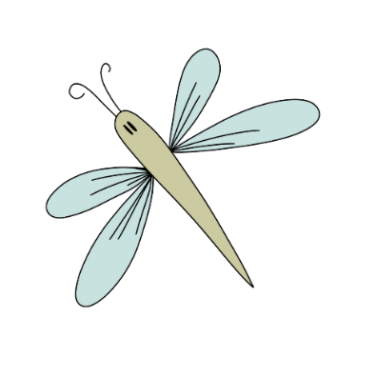
All About Me
My Name is: ______________
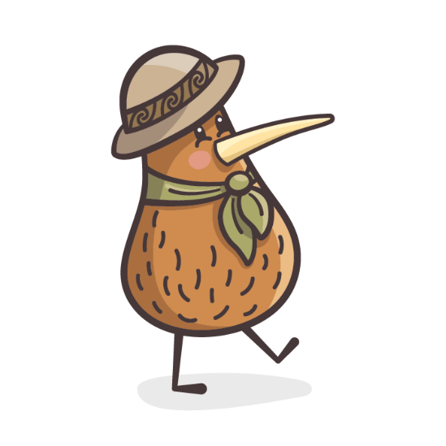
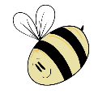
The people that I live with:
In new situations I normally:
What will help comfort me when I’m sad?
My sleep routine, and what helps me go to sleep (cuddly/dummy):
Where am I at with toileting:
Things I can do by myself:
Things you would like me to be able to do by myself:
My favourite things to do are:
My favourite things to eat are:
Food that I find yucky:
Something super special about me:
Tell us about your family’s cultural heritage & any special days you celebrate:

