My Name is: ______________
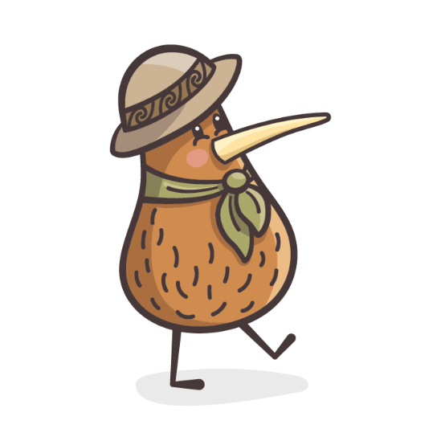

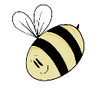
The people that I live with are:
In new situations I normally:
What will help comfort me when I’m sad?
My sleep routine:
What helps me go to sleep (cuddly/dummy):
How long do I sleep for?
My Bottles – Cows Milk, Formula or Breast Milk?
What time do I have my bottle:
Measurement:
Do I have any food likes or dislikes?
Allergies or Intolerances:
My favourite things to do are:
Tell us about your family’s cultural heritage & any special days you celebrate:

